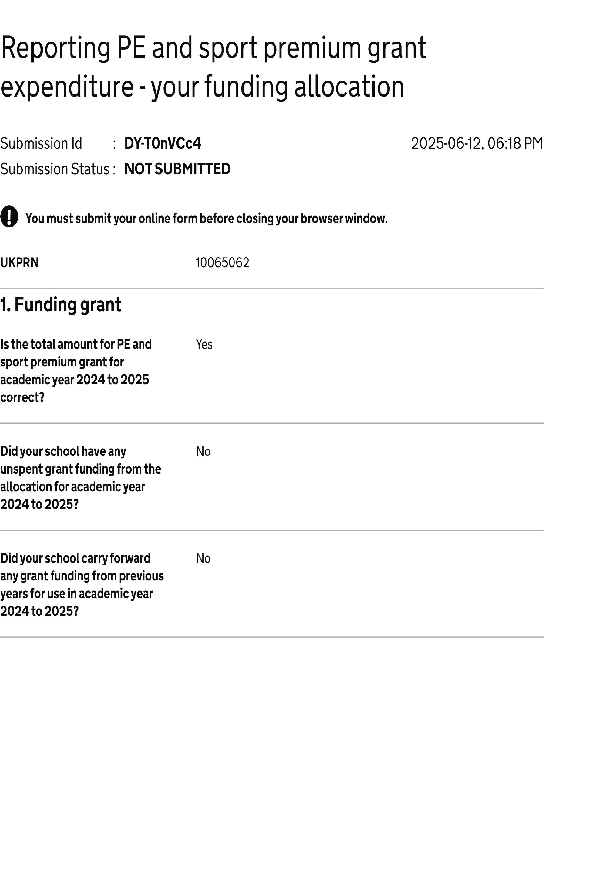
Reporting PE and sport premium… DY-T0nVCc4 Page 1 of 2

Reporting PE and sport premium… DY-T0nVCc4 Page 2 of 2

